**IST659 – Data Admin Concepts & Db Mgmt**

**Lab 6 - Ramasamy Seenivasagamani – Sanjeev**

Find all candidates who were interviewed for second round (Round Number = 2)

Internship position. Show each candidate’s details which includes candidate ID,

candidate name, phone number, candidate experience, and relevant experience.

--#a

select * from Candidate

join

Interview on Candidate.CandidateId=Interview.CandidateId

join

Position on Interview.PositionId=Position.PositionId where Position.PositionLevel='Internship' and Interview.RoundNumber=2

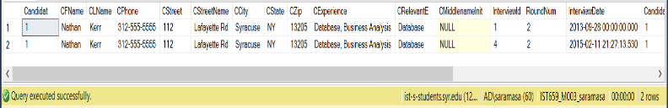

Find all positions whose interviews were conducted by "Amy May"(interviewer).

Show the PositionId, position level, position name and position availability.

--#b

select Position.PositionId, Position.PositionLevel, Position.PositionName, Position.PositionAvailable from Position

join

Interview on Interview.PositionId=Position.PositionId

join

Interviewer on Interview.InterviewerId=Interviewer.InterviewerId where Interviewer.IFName='Amy' and Interviewer.ILName='May'

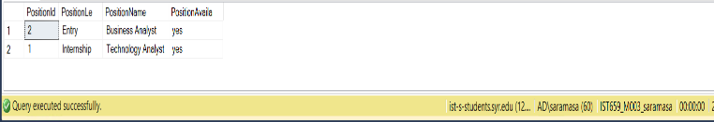

Find all interviewers who conducted one or more second-round interviews. Show the

Interviewer details like Interviewer ID, Interviewer phone, Intervieweremail,

Interviewer address and schedule.

--#c

select Interviewer.InterviewerId, Interviewer.IPhone, Interviewer.IEmail, Interviewer.IStreetno, Interviewer.IStreetName, Interviewer.ISchedule from Interviewer

join

(select count(RoundNumber) as Count, b.InterviewerId from Interview b where b.RoundNumber=2 group by b.InterviewerId having count(b.RoundNumber)>=1) as abc

on Interviewer.InterviewerId=abc.InterviewerId

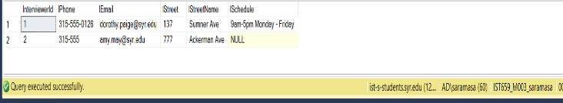

Find all candidates who interviewed for the position “Advisory Consultant”. Show

Candidate details and interview details.

--#d

select c.*, i.* from Candidate c

join

Interview i on c.CandidateId=i.CandidateId

join

Position p on p.PositionId=i.PositionId where p.PositionName='Advisory Consultant'

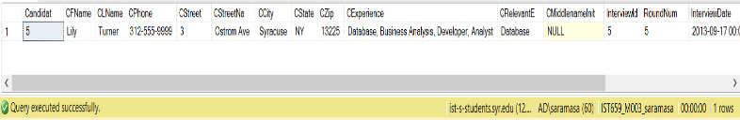

Find positions for all the interviews that were conducted on September 28th, 2013.

Show the PositionId, position level, position name and position availability.

--#e

select p.PositionId,p.PositionName, p.PositionLevel, p.PositionAvailable from Position p

join

Interview i on p.PositionId=i.PositionId where InterviewDate = '2013-09-28'

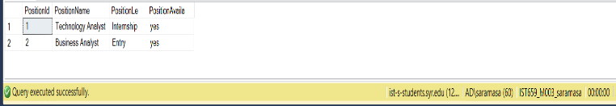

Find all positions for which no interviews were conducted, and delete them from the

Position table.

--f

select p.* from Position p where PositionId not in (select i1.PositionId from Interview i1)

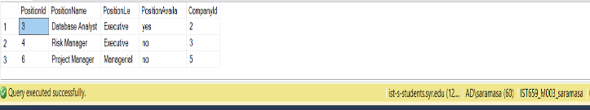

Find the interviewer who conducted the interview for candidate "Heather Cameron".

Update this interviewer's phone number to 315-400-5000.

--Deleting the Possitions from the Position Table

delete from Position

where PositionId in (select p.PositionId from Position p where PositionId not in (select i1.PositionId from Interview i1))

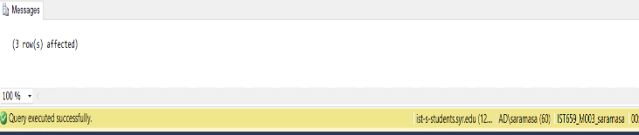

**g.**

select i1.* from Interviewer i1

join

Interview i2 on i1.InterviewerId = i2.InterviewerId

join

Candidate c on i2.CandidateId=c.CandidateId where c.CFName='Heather' and c.CLName='Cameron'

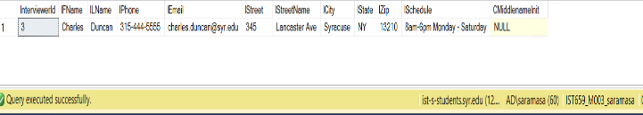

update Interviewer

set IPhone='315-400-5000' where InterviewerId in (select i1.InterviewerId from Interviewer i1

join

Interview i2 on i1.InterviewerId = i2.InterviewerId

join

Candidate c on i2.CandidateId=c.CandidateId where c.CFName='Heather' and c.CLName='Cameron'

)

